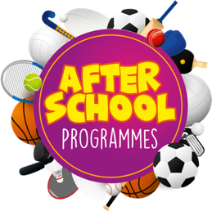
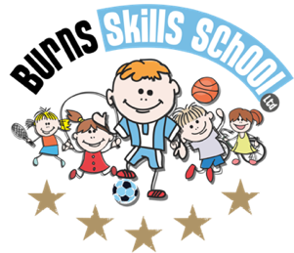
Basketball

Dear Parent/Guardian
We are delighted to announce that Burns Skills School are running one of their fantastic afterschool programmes within the school grounds this year. The programme will consist of 6 weeks which will entail age appropriate educational sessions that will have a main focus of fun whilst improving each child’s technical ability.
Dates of programme:
Monday 17th April
Monday 24th April
Monday 15th May
Monday 22nd May
Monday 5th June
Monday 12th June

Primary 1 – Primary 2 (1.30pm-2.30pm each week)
Primary 3 – Primary 7 (2.30pm-3.30pm each week)

To secure a place for your child you must enrol online via www.burnsskillsschool.co.uk This is very easy and straightforward. Click ‘secure your place’ at the top of the website. Then scroll down to find your child’s school and the correct activity to enrol. Cost: £24.00.

Deadline for payment is Sunday 16th April. This is a great opportunity for your child and certainly one not to be missed. When in attendance we would advise that all children wear appropriate clothing with a pair of trainers suitable for indoor and outdoor.

Payment options: Online

TERM 3 PRIZE

WIN a trip to Old Trafford to watch Manchester United vs Wolves on Saturday the 13th of May. This prize includes flights and a one night stay in Manchester. Each child who signs up to one of our after-school programmes will automatically be entered into this FREE draw. Keep your eyes peeled on our social media for the date and time of the draw.

v
Thanks
Aaron & Andrew
Burns Skills School

