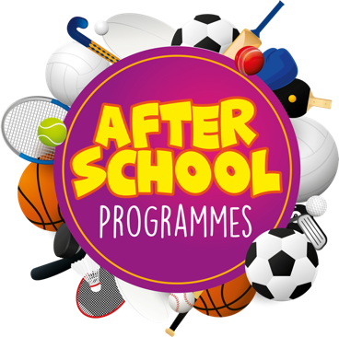
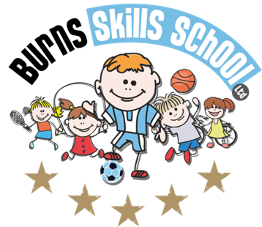
Multisport

Dear Parent/Guardian
We are delighted to announce that Burns Skills School are running one of their fantastic afterschool programmes within the school grounds this year. The programme will consist of 5 weeks which will entail age appropriate educational sessions that will have a main focus of fun whilst improving each child’s technical ability.
Dates of programme:
Wednesday 27th April
Wednesday 4th May
Wednesday 11th May
Wednesday 18th May
Wednesday 25th May

To secure a place for your child you must enrol online via www.burnsskillsschool.co.uk This is very easy and straightforward. Click ‘secure your place’ at the top of the website. Then scroll down to find your child’s school and the correct activity to enrol. Cost: £20.00. Only 20 places MAXIMUM available for each session.

Primary 1 - Primary 2 (1.30pm-2.30pm each week). Primary 3 - Primary 7 (2.30pm-3.30pm each week).

Note: You do not need to print any tickets off our website.

Benefits of programme:

- Improves technical ability
- Enhances physical, mental and social attributes (confidence building)
- Professional coaching
- Controlled and structured physical activity
- Teaches respect for one and all
- Make new friends

Deadline for forms & payment is Tuesday 26th of April. This is a great opportunity for your child and certainly one not to be missed. When in attendance we would advise that all children wear appropriate clothing with a pair of trainers suitable for indoor and outdoor.

Payment options: PayPal (Please select friends & family)

Thanks
Aaron & Andrew
Burns Skills School

