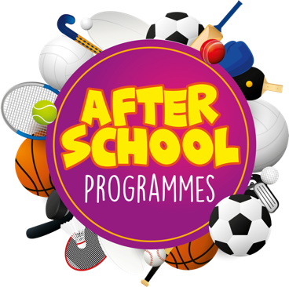
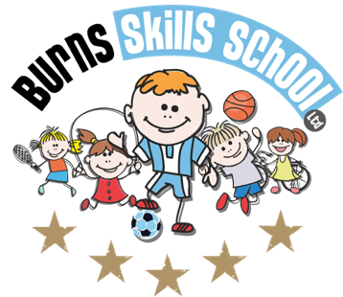
Basketball

Dear Parent/Guardian
We are delighted to announce that Burns Skills School are running one of their fantastic afterschool programmes within the school grounds this year. The programme will consist of 10 weeks which will entail age appropriate educational sessions that will have a main focus of fun whilst improving each child’s technical ability.
Dates of programme:
Monday 17th Jan
Monday 24th Jan
Monday 31st Jan
Monday 7th Feb
Monday 21st Feb
Monday 28th Feb
Monday 7th Mar
Monday 14th Mar
Monday 21st Mar
Monday 28th Mar

To secure a place for your child you must enrol online via www.burnsskillsschool.co.uk This is very easy and straightforward. Click ‘secure your place’ at the top of the website. Then scroll down to find your child’s school and the correct activity to enrol. Cost: £40.00. Only 20 places MAXIMUM available for each session.

Primary 1 - Primary 2 (1.30pm-2.30pm each week). Primary 3 - Primary 7 (2.30pm-3.30pm each week).

Note: You do not need to print any tickets off our website.

Benefits of programme:

- Improves technical ability
- Enhances physical, mental and social attributes (confidence building)
- Professional coaching
- Controlled and structured physical activity
- Teaches respect for one and all
- Make new friends

Deadline for forms & payment is Monday 17th of January. This is a great opportunity for your child and certainly one not to be missed. When in attendance we would advise that all children wear appropriate clothing with a pair of trainers suitable for indoor and outdoor.

Payment options: PayPal (Please select friends & family)

Thanks
Aaron & Andrew
Burns Skills School

