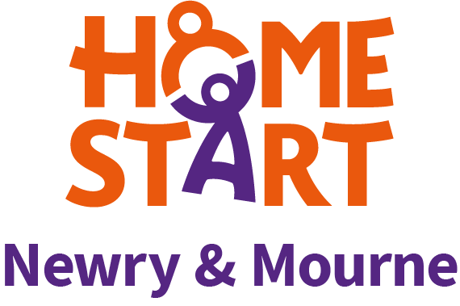
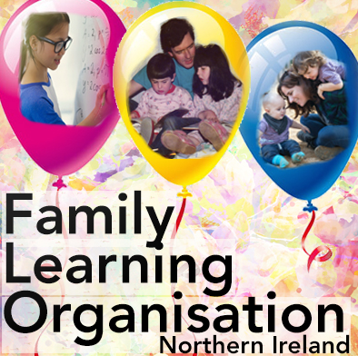 in association with

EMAIL: flo.nireland@gmail.com FACEBOOK: @FLO.NIreland TWITTER: @IrelandFlo

Dear Principal,

Enabling teachers, parents and children to continue learning during the Covid-19 pandemic

THE FAMILY LEARNING ORGANISATION – FLO HAS BEEN WORKING WITH TEACHERS, PARENTS/CARERS AND YOUNG PEOPLE FOR OVER TEN YEARS. However, due to the pandemic, FLO has now gone online to ensure that parents and children can be offered support despite the enforced restrictions. It is offering a series of 3 programmes.

FLO SESSIONS IN Jan/Feb 2021: EACH WILL LAST 90 MINUTES
(Registration is now open via email to flo.nireland.gmail.com)

LIZ Jones
DATE: TUESDAY 26TH JANUARY AT 8.00PM
Title: Emotions: Mind, Brain & Body
The session will raise awareness of children & young people’s Mental Health, promote positivity and discuss strategies to help overcome emotional distress.

KATE O’Hanlon
DATE: TUESDAY 2ND FEBRUARY AT 8.00PM
Title: Word Blindness:
Understanding and supporting those who find reading and writing challenging and who may have the specific features of dyslexia.

COLETTE Delargy
DATE: TUESDAY 9th FEBRUARY AT 8.00PM
Title: Can’t Do Maths?
A look at why children might struggle with maths and what can be done to boost their knowledge, understanding and confidence.

FLO TEAM

With a career in nursing, midwifery, mental health, health visiting and teaching, Liz Jones has drawn on her wealth of knowledge, experience and previous research to promote child-centred parenting. Through the Family Learning Organisation, Liz will focus on the family and will explore techniques and strategies that work best for families in these challenging times.

Kate O’Hanlon, a member of the Family Learning Organization for over ten years, is a teacher, psychologist, researcher and accredited trainer of Instrumental Enrichment, a programme dedicated to developing the thinking skills of young people, particularly those who find learning more challenging. Her areas of interest are language and literacy, young people who may be dyslexic and encouraging a focus on thinking skills

As a teacher, adviser and tutor, Colette Delargy has devoted her working life to finding ways of making Maths more accessible to people. She particularly enjoys helping children who think they can’t do Maths overcome their difficulties and succeed with a newfound confidence. As a member of the Family Learning Organisation, Colette will show parents easy, fun activities they can do at home to help their children become better at Maths.

WE ARE OFFERING THESE PROGRAMMES IN ASSOCIATION WITH HOME START

FLO ONLINE: Flo has recorded 3 short taster videos presenting aspects of our work which may help you decide if this programme is suitable for your school community. You can click & view these on YouTube:
FLO YouTube Channel

OFFER TO SCHOOLS
Payment of a one-off fee of £100 will allow schools (and associated parents, governors and staff) to access any or all 3 of the sessions detailed above.
The presentations will be of interest to parents/carers, teachers and anyone involved in the development and learning of children and young people.

REGISTRATION

- Email your school’s interest to flo.nireland@gmail.com
- Indicate the course or courses you wish to attend
3. Payment is via 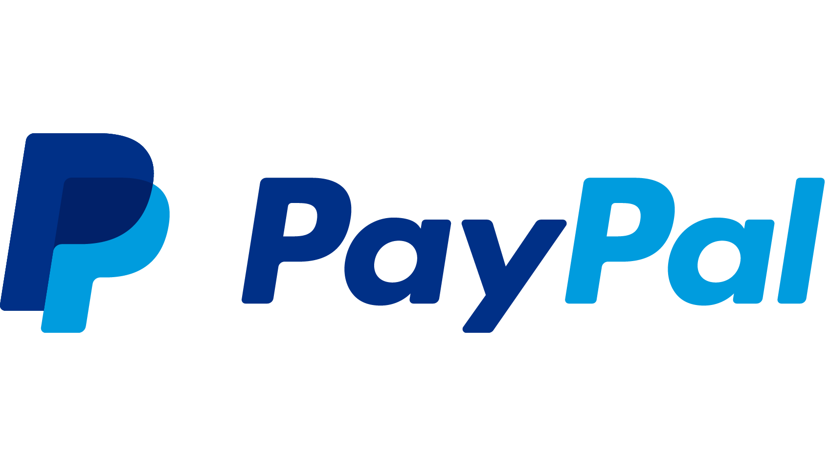 or direct debit at the following link https://py.pl/22t8BG

Those who opt in will receive the Zoom link the day before each event.

We look forward to hearing from you.

Colette Delargy
Liz Jones
Kate O’Hanlon.

January 2021.

