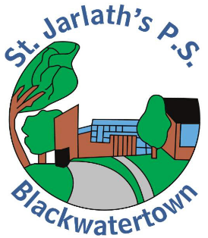
FIRE DRILL PROCEDURE
SIGNAL: Continuous sounding of electronic bell

PROCEDURE DURING CLASS TIME
- Pupils exit classroom via the following doors:
  - P1 – P3: own classroom doors
  - P4 and P7: Front door
  - P5 and P6: Side door
- Pupils assemble at the following assembly areas:
  - P1 – P3: Along the new tarmac area beside the perimeter fence, close to the gate
  - P4 and P7: in the bus turning circle
  - P5 and P6: in far corner of staff carpark. (Exiting through the double gates)

Teachers:
  - Take your CLASS LIST
  - Check that all pupils are out of the classroom
  - Check that all exits are clear
  - CLOSE classroom door

- In the assembly area teacher takes roll and accounts for each child
- Pupils in classrooms other that their own remain with that class until given permission to rejoin their class
- Pupils remain in orderly and silent lines until a clear signal is given by the Principal/Vice Principal to either return to school or remain outside of school grounds.

PROCEDURE USED DURING BREAK & LUNCH
- Pupils walk to where they usually line up in the yard
- Pupils wait in orderly and silent lines for their teacher, or other supervising adult, to lead them to their proper assembly area.
PROCEDURE DURING PE
Teacher, or other supervising adult, stops play, organises class(es) into silent and orderly lines and leads class(es) to the nearest exit and assembly point to them. If in the assembly hall this will be the door on the right hand side towards the bottom area.
PROCEDURE WHEN NOT IN YOUR OWN CLASSROOM
- Teachers should be familiar with assembly area and evacuation route designated for that classroom or area.
- That day’s class list should accompany the class and used by the teacher, or other supervising adult, to account for all pupils.
ALL SCHOOL PERSONNEL, ARE TO PARTICIAPTE IN ALL FIRE DRILLS.
Parents, guests and visitors on school grounds during a drill MUST participate.

