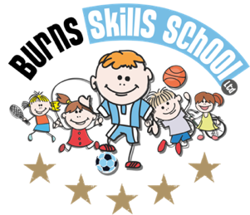
Football

Dear Parent/Guardian
We are delighted to announce that Burns Skills School are running one of their fantastic afterschool programmes within the school grounds this year. The programme will consist of 10 weeks which will entail age appropriate educational sessions that will have a main focus of fun whilst improving each child’s technical ability.
Dates of programme:
Wednesday 18th Jan
Wednesday 25th Jan
Wednesday 1st Feb
Wednesday 8th Feb
Wednesday 22nd Feb
Wednesday 1st Mar
Wednesday 8th Mar
Wednesday 15th Mar
Wednesday 22nd Mar
Wednesday 29th Mar

Primary 1 - Primary 2 (1.30pm-2.30pm each week) Primary 3 - Primary 7 (2.30pm-3.30pm each week)

To secure a place for your child you must enrol online via www.burnsskillsschool.co.uk This is very easy and straightforward. Click ‘secure your place’ at the top of the website. Then scroll down to find your child’s school and the correct activity to enrol. Cost: £40.00.

Note: £20.00 will be due up front and then a second payment of £20.00 will be due in February. You will be notified via email when the second payment is due.

Benefits of programme:

- Improves technical ability
- Enhances physical, mental and social attributes (confidence building)
- Professional coaching
- Controlled and structured physical activity
- Teaches respect for one and all
- Make new friends

Deadline for payment is Sunday 15th January. This is a great opportunity for your child and certainly one not to be missed. When in attendance we would advise that all children wear appropriate clothing with a pair of trainers suitable for indoor and outdoor.

Payment options: PayPal

Thanks
Aaron & Andrew
Burns Skills School

