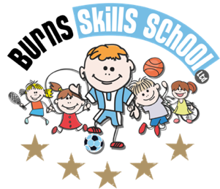
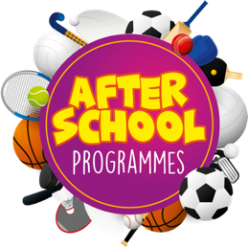
Multisport

Dear Parent/Guardian
We are delighted to announce that Burns Skills School are running one of their fantastic afterschool programmes within the school grounds this year. The programme will consist of 10 weeks which will entail age appropriate educational sessions that will have a main focus of fun whilst improving each child’s technical ability.
Dates of programme:
Monday 16th Jan
Monday 23rd Jan
Monday 30th Jan
Monday 6th Feb
Monday 20th Feb
Monday 27th Feb
Monday 6th Mar
Monday 13th Mar
Monday 20th Mar
Monday 27th Mar

Primary 1 - Primary 2 (1.30pm-2.30pm each week) Primary 3 - Primary 7 (2.30pm-3.30pm each week)

To secure a place for your child you must enrol online via www.burnsskillsschool.co.uk This is very easy and straightforward. Click ‘secure your place’ at the top of the website. Then scroll down to find your child’s school and the correct activity to enrol. Cost: £40.00.

Note: £20.00 will be due up front and then a second payment of £20.00 will be due in February. You will be notified via email when the second payment is due.

Benefits of programme:

- Improves technical ability
- Enhances physical, mental and social attributes (confidence building)
- Professional coaching
- Controlled and structured physical activity
- Teaches respect for one and all
- Make new friends

Deadline for payment is Sunday 15th January. This is a great opportunity for your child and certainly one not to be missed. When in attendance we would advise that all children wear appropriate clothing with a pair of trainers suitable for indoor and outdoor.

Payment options: PayPal

Thanks
Aaron & Andrew
Burns Skills School

