A big hello to all my Primary 3 children,

I am writing to wish all of you a wonderful and exciting summer and to say thank you for making this school year so rewarding and enjoyable for me. I feel extra lucky as this was my second year to teach you and to see everyone grow and develop from Primary 1 was just amazing.
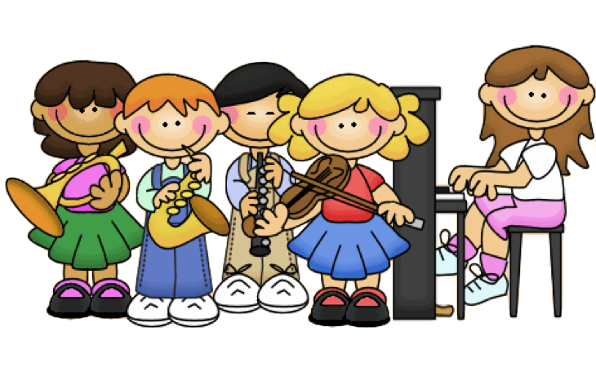
This year we made wonderful memories which I hope you will remember forever. We invented our Primary 3 break time and lunch time ball games, improved our numeracy skills with the daily morning game and listened to music and drew how it made us feel!! We performed fabulous Halloween and St. Patrick Day Assemblies, learned how to play the tin whistle and enjoyed many days out with the Cope Primary School. We also explored in the snow before it melted away!! Even with all these fun activities we still managed to learn lots of new number skills and improve our reading and writing.
Sadly, in March our time in class was cut short but my brilliant primary 3 children still continued to learn from home with super help from parents, grandparents and even brothers and sisters. I was delighted with all the tasks completed and really looked forward to marking your beautiful work on Seesaw.
I have really missed all of my primary 3 children, especially your happy faces, your class achievements and our little chats.
During the summer I want you all to play outside each day and make more fun memories with your family. Hopefully we will see plenty of sunshine and you will get out for lots of walks and bike rides.
I hope you enjoy looking at the photos that I have included. They certainly made me smile!
Continue to stay safe and I hope to see you all soon.

Take care
Ms. Monaghan

