St Jarlath’s Primary
Accessing books to read for AR:

Part 1- REGISTERING WITH LIBRARIES NI:

Step 1:
If your child has access to their library card you can skip to part 2.

Step 2:
Some of the children may have misplaced their card or left it in school.
In this instance you can register (as a parent) for libraries NI and download an EBOOK.

Step 3:
Click the following link:
https://www.librariesni.org.uk/Pages/default.aspx

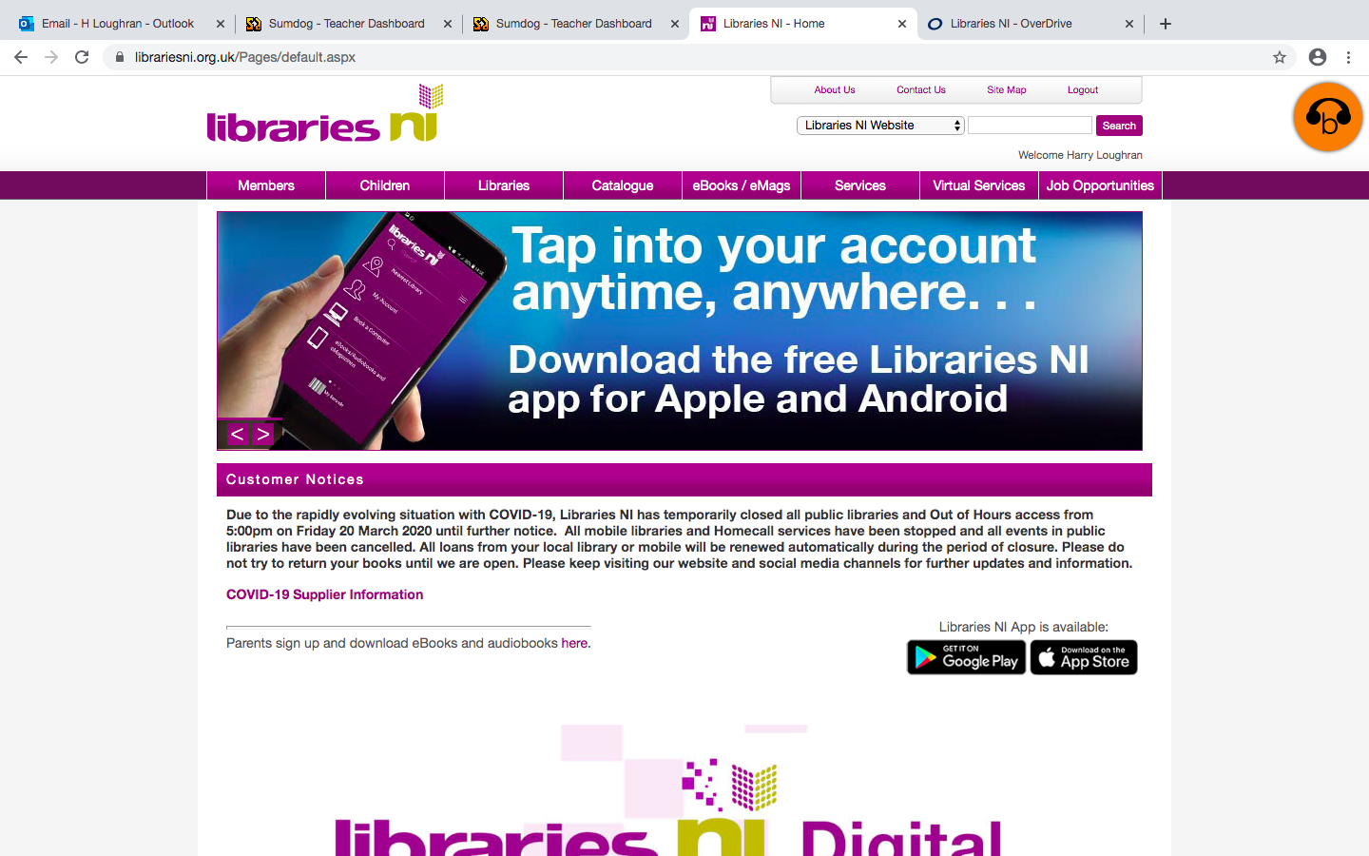

Step 4:
Click on ‘ebooks/emags’

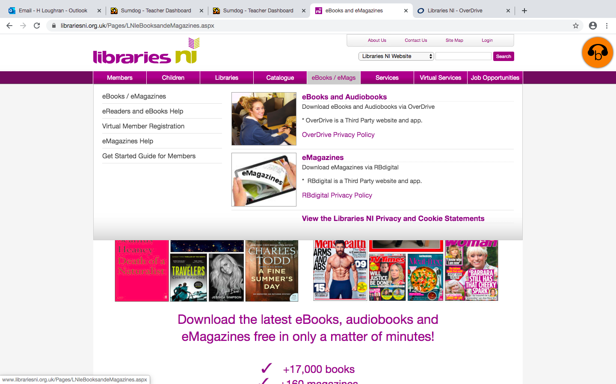
Step 5:
Scroll down and select ‘Get a Membership Number’

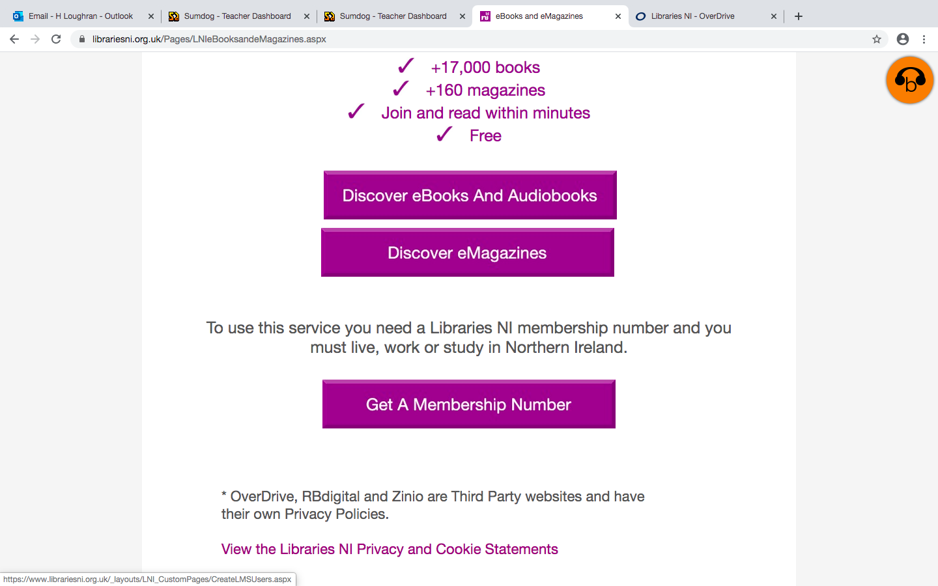

Step 6:
Enter your details (parent details) and select ‘Create New Account’:
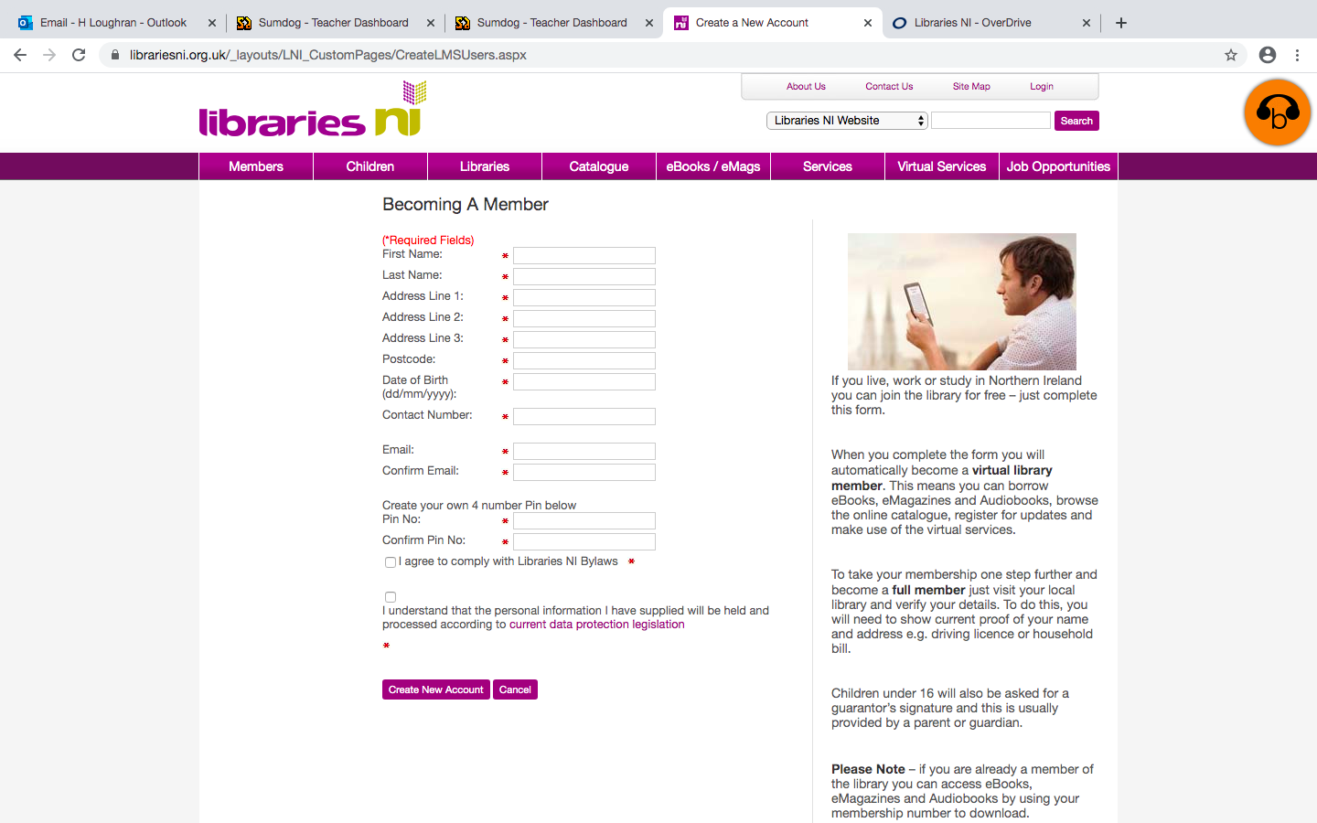

Step 7:
You will be asked to create a four-digit pin.
You should then take note of your membership number.
These are the two details you will need.
Select ok.
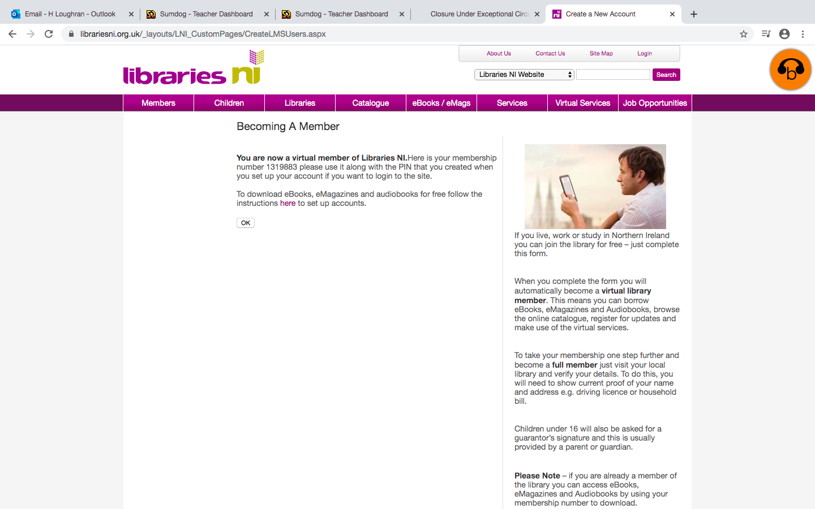

Part 2: DOWNLOADING EBOOK:

- If you are using a tablet:
Step 1: Download Overdrive app from app store:

Step 2: Choose under 13 ‘continue’
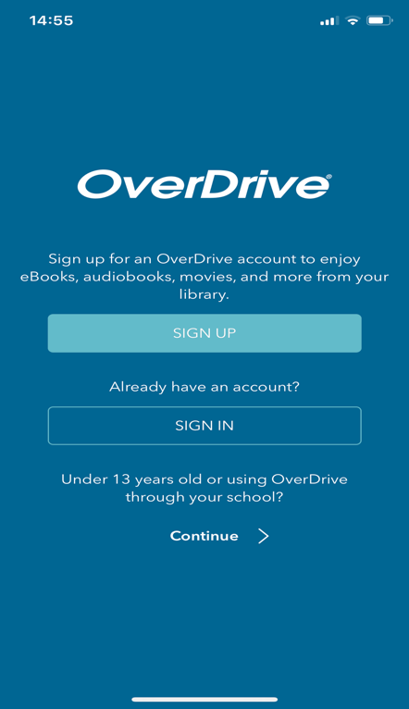

Step 3:
Click Add to library
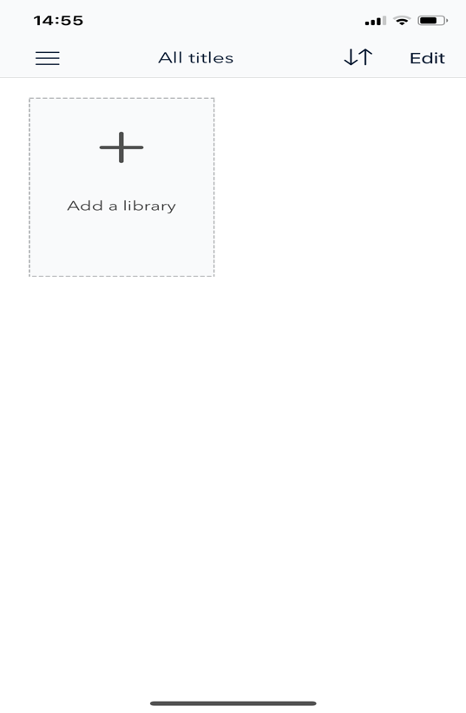

Step 4: Search Armagh
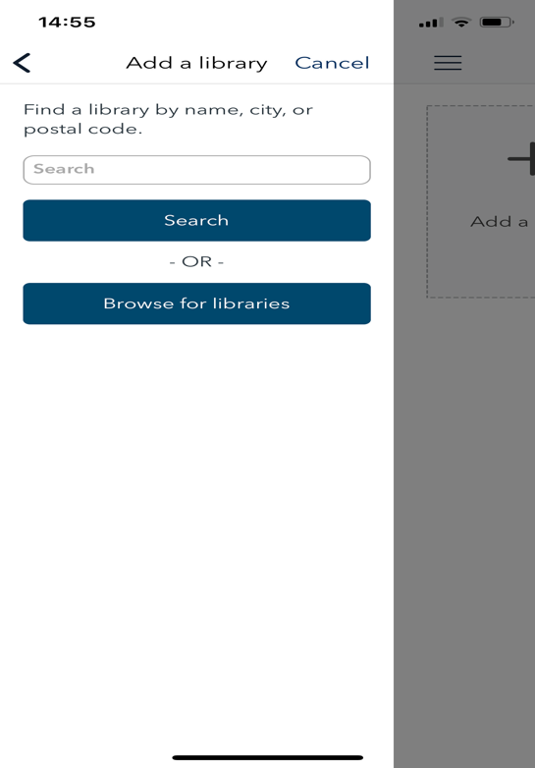
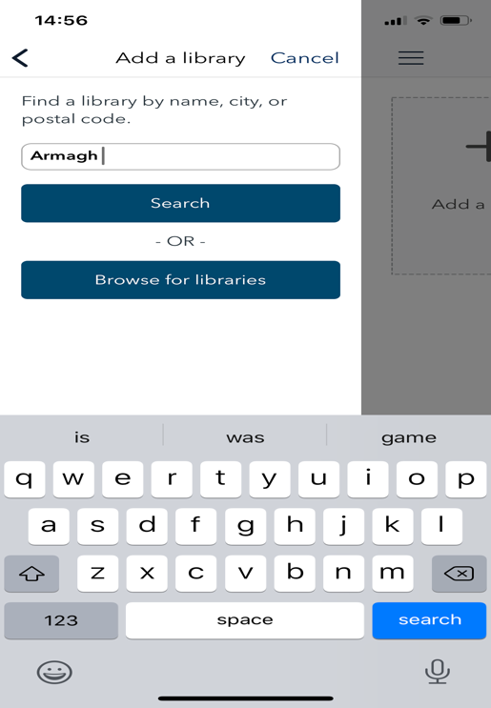

Step 5:
Select Armagh Library

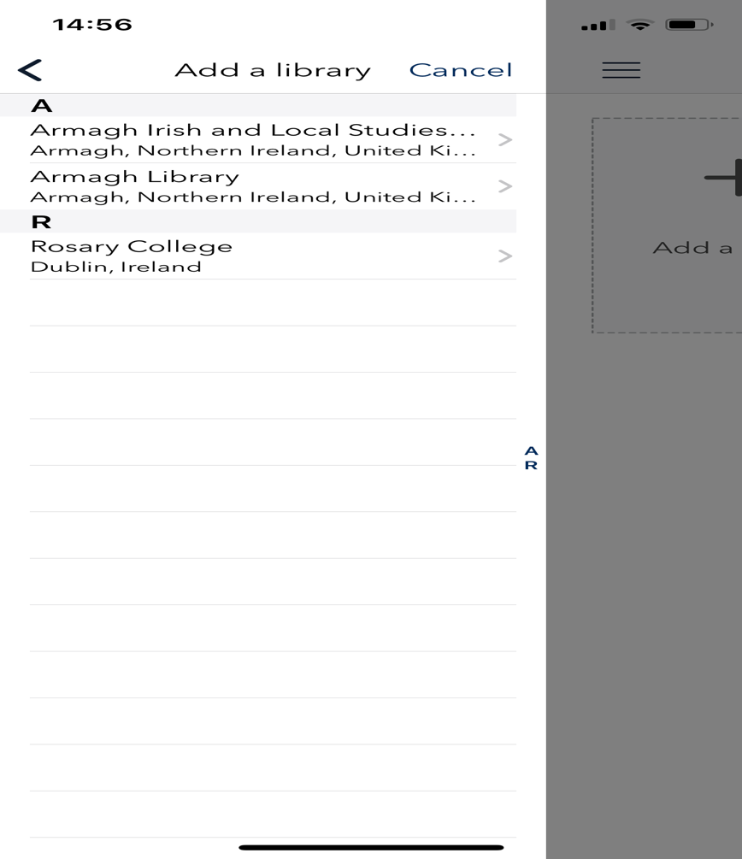
Step 6:
Select LibrariesNI
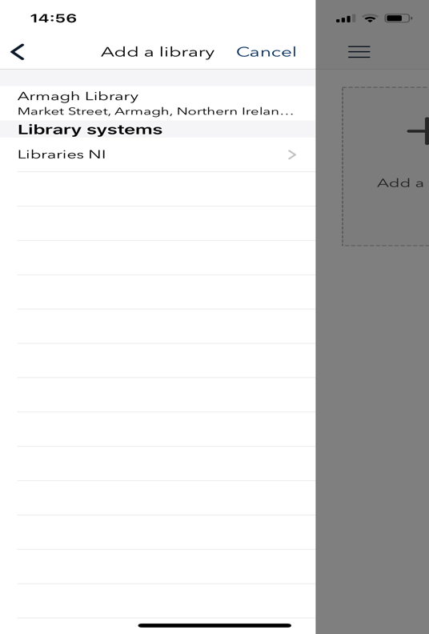

Step 7:
Confirm Cookies
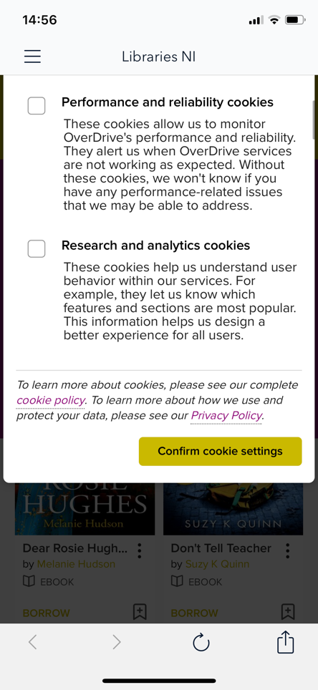

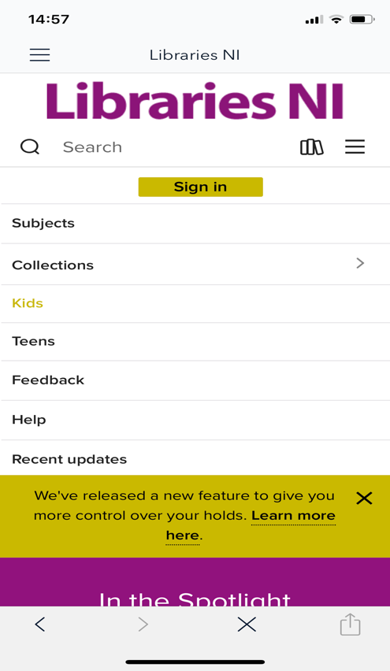
Step 8: Select Kids from the drop down menu:

Step 9:
Choose your book when you are sure it is the correct level (more on this in part 3).
Click Borrow on the book.
It will then ask you to sign in with the account you created in part 1 or using your child’s existing card.
Select the period you would like to borrow for and download your book to your tablet. You can then begin to read.

- If you are using a laptop:

Step 1:
Click on link:

https://librariesniuk.overdrive.com/

Step 2:

Click Borrow on the book you like when you are sure it is the correct level (more on this in part 3).
It will then ask you to sign in with the account you created in part 1 or using your child’s existing card.
Select the period you would like to borrow, click download and confirm.
You can then begin to read.
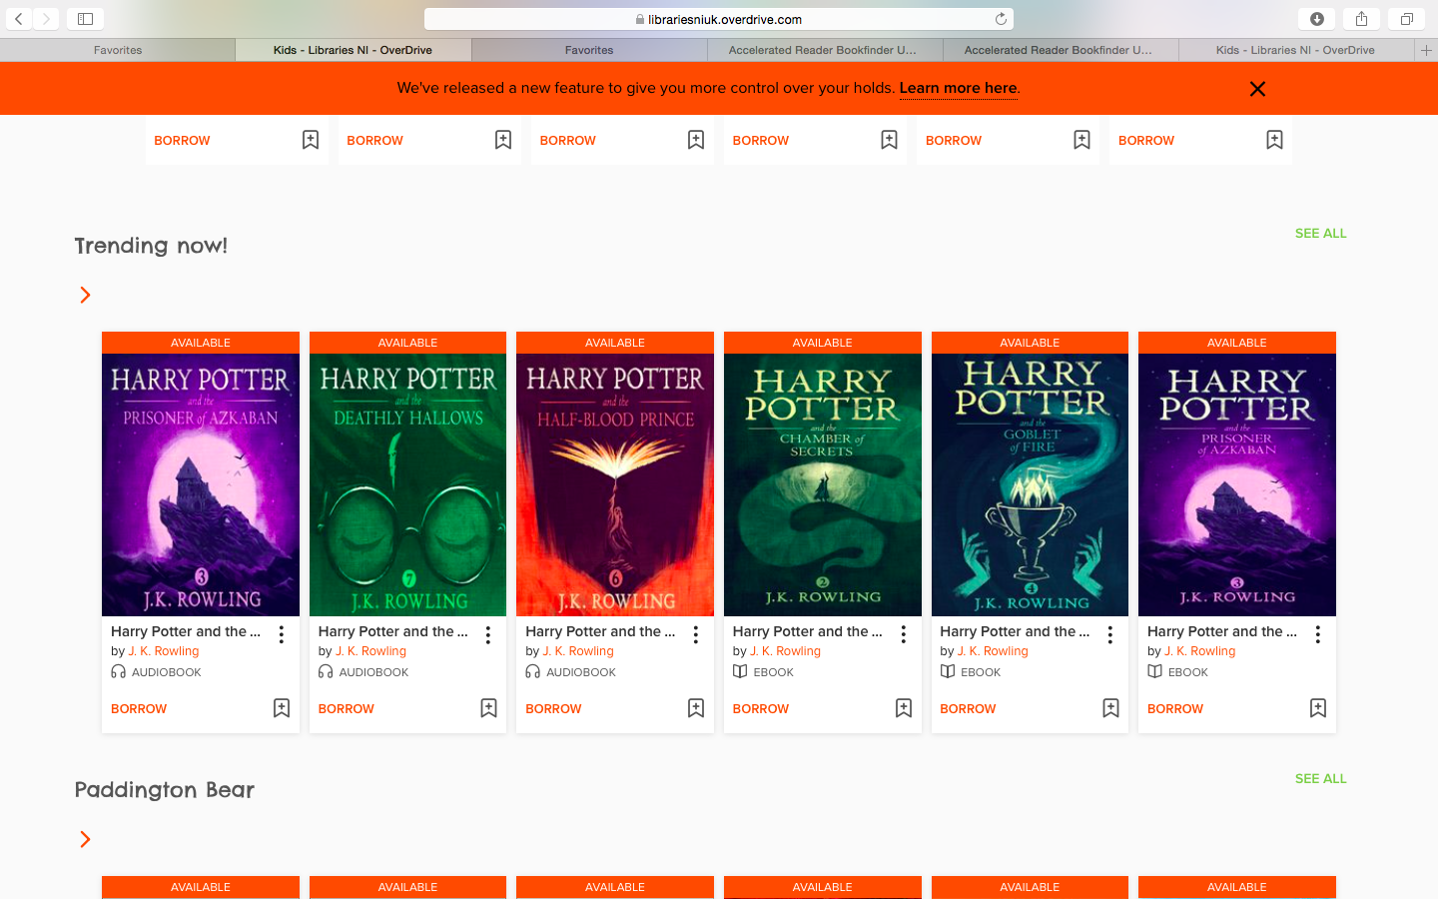

Part 3- CHECKING THE BOOK IS AN APPROPRIATE LEVEL FOR YOUR CHILD:

Step 1:
You will need to support your child in selecting books at the appropriate level. To assist with this, you will be provided with a "Book level Scale". This is specific to your child and was included in each pupil’s curriculum pack. This "Book Level Scale" is used to ensure pupils are selecting books at the appropriate level. It is vitally important that the books selected for your child fall within this scale as this is the level which will allow your child to make progress. Ordinarily, books in our school library are colour banded to support pupils in selecting appropriate books. As this is unavailable, you will need to support your child. You can use the AR book find resource to do this. This can be accessed through
https://www.arbookfind.co.uk/UserType.aspx?RedirectURL=%2fdefault.aspx

Step 2:
Select 'Parent' (and submit)
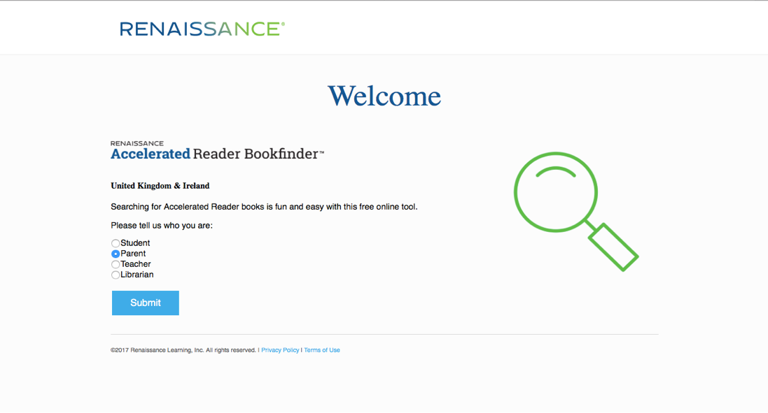

Step 3:
Search for book title: eg Harry Potter and Half-Blood Prince.
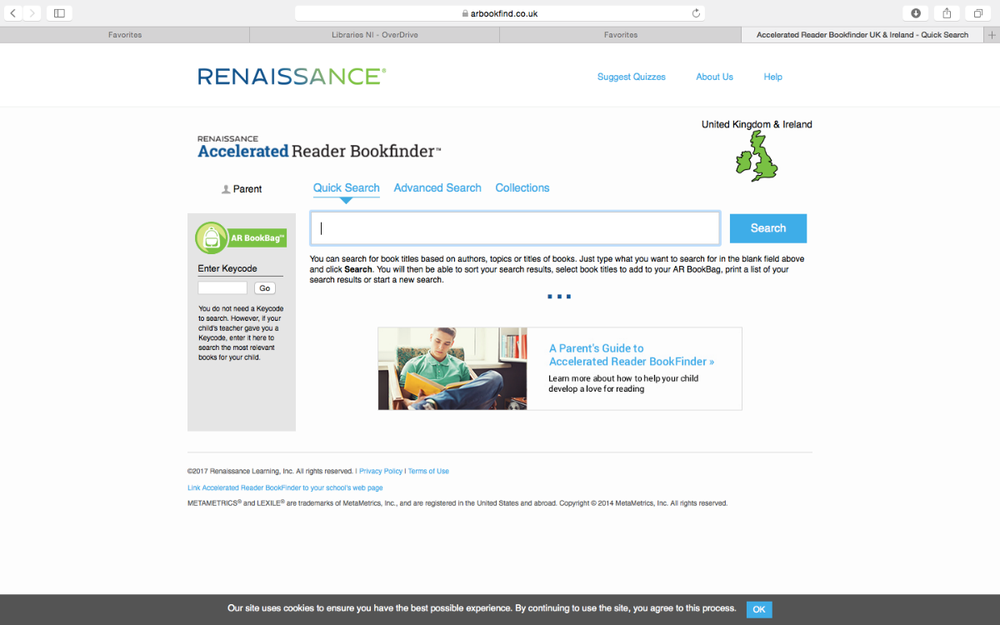

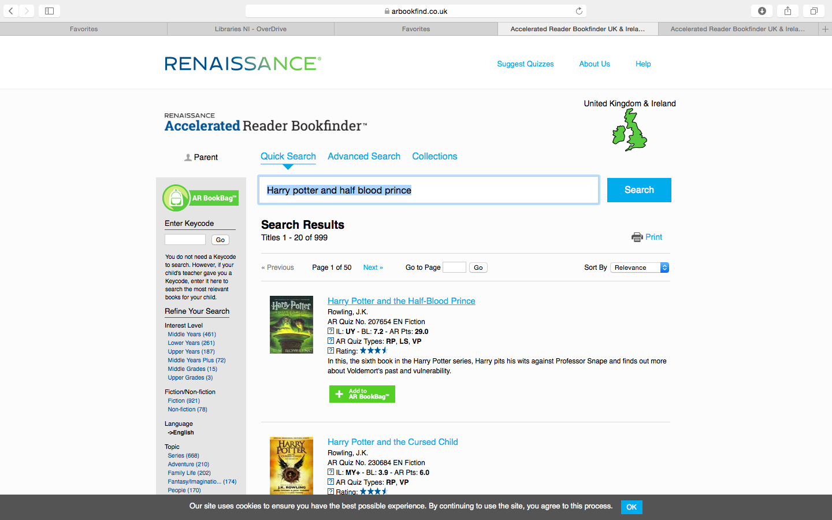

Step 4:
When we zoom in we can see that the BL is 7.2.
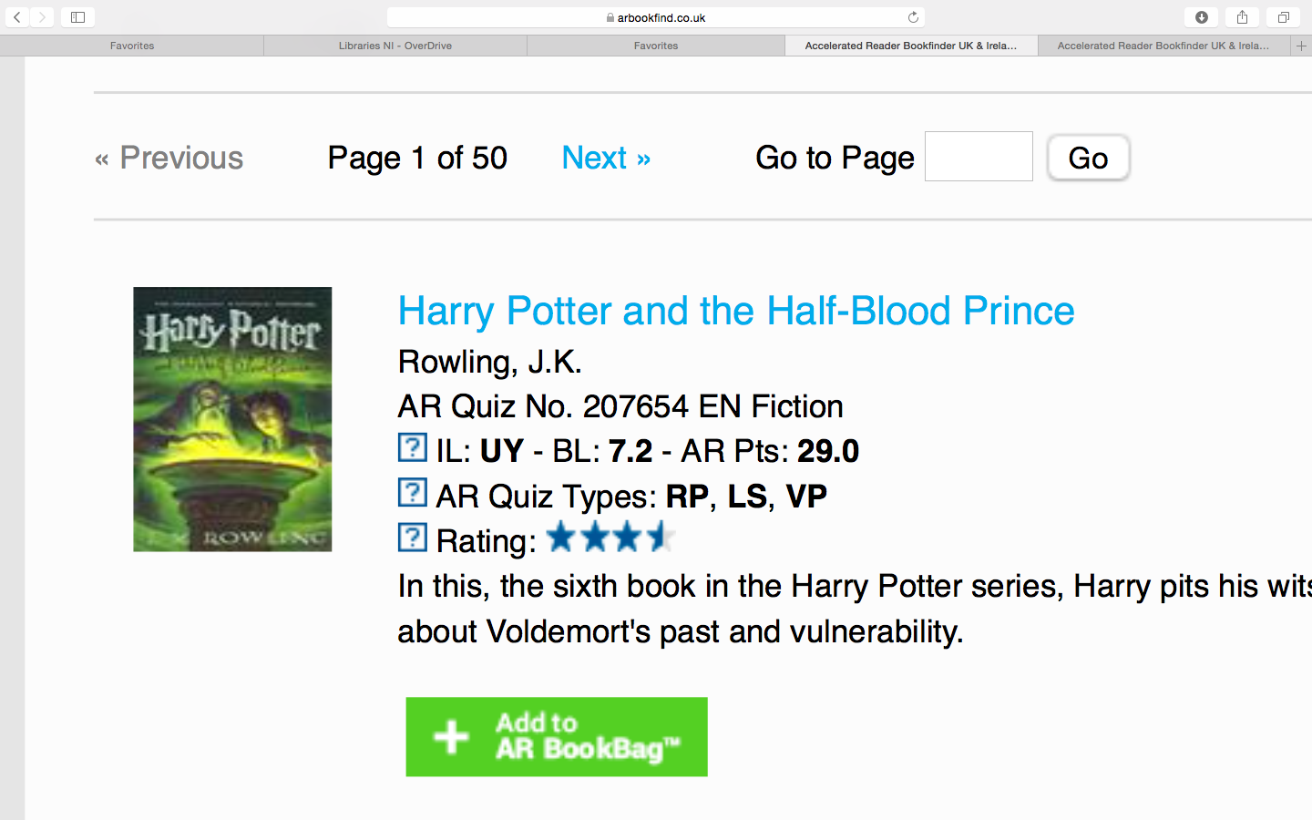
Therefore, if your child has a book level of 4.5-6.5, this book will be too difficult.

