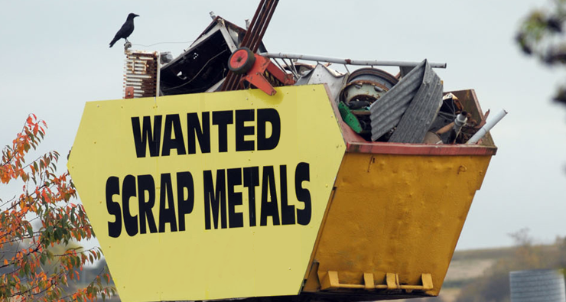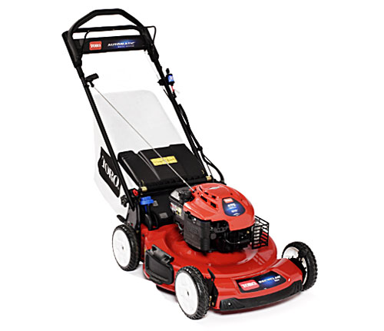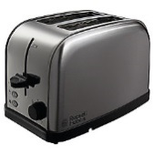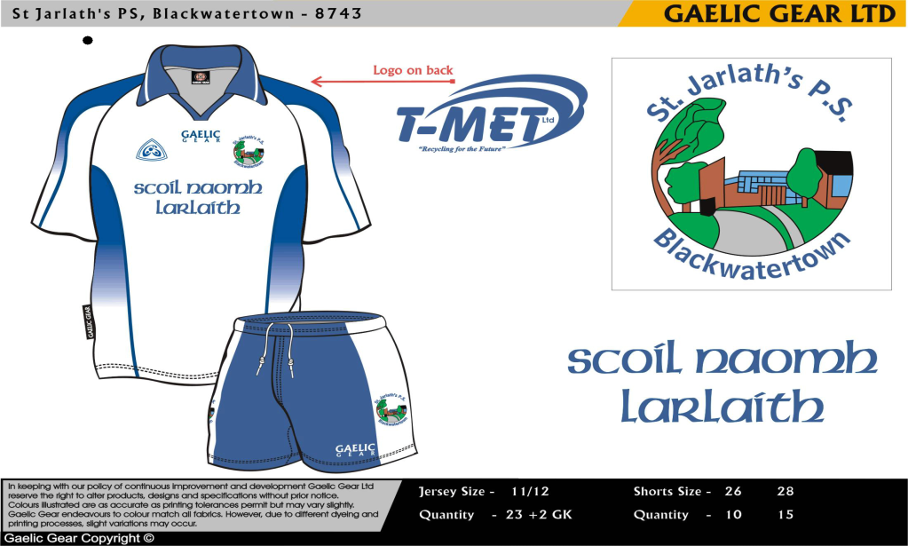

**Saturday 1st June**

9AM-5PM

**St. Jarlath’s Primary School**

**Eco Committee**

**Blackwatertown**

**All Scrap Metal**

* **Old electrical goods**
* **Old lawnmowers ETC.**

**CARETAKER WILL BE IN**

**ATTENDANCE TO HELP**