St Jarlath’s PS

Period Dignity and Menstrual Well-Being

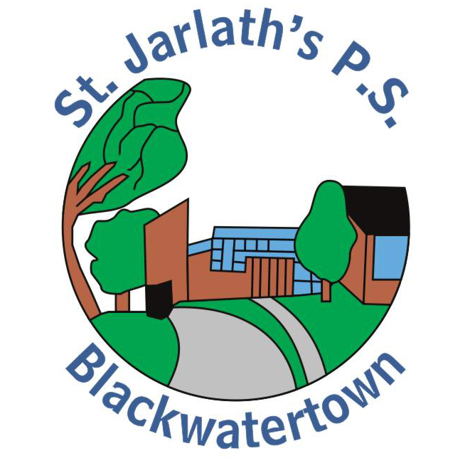

Aims of the Policy:
This policy will address the importance of accessibility and availability of essential care in St Jarlath’s Primary School.
We aim to ensure that
• Pupils are provided with facts about menstruation;
• Children are given a comprehensive understanding of menstrual wellness, and how this impacts physical and emotional wellbeing
• We educate children about menstrual hygiene – essential facts and how to deal with related situations
• Negative attitudes, myths and stereotypes are challenged

This policy has been developed in line with the following guidance: The Equality Act (Sexual Orientation) Regulations (Northern Ireland) 2006 www.legislation.gov.uk –
United Nations Convention on the Rights of the Child (UNCRC) (www.unicef.org.uk) –
Every School a Good School
Together Towards Improvement and Community Relations,
Equality and Diversity in Education Policy (www.deni.gov.uk) –
Menstrual Well-being in the RSE Curriculum https://ccea.org.uk/learningresources/relationships-and- sexuality-education-rse/menstrual-wellbeing
The policy will be reviewed September 2025 by the Period dignity key contact (Ms Smyth ) and the Principal (Mrs Loughran).

Our Ethos:
Staff at St Jarlath’s PS are highly committed to the care and well-being of each child, have a deep sense of pride in our school and community, and work together to contribute to the holistic development of all children entrusted to our care. We seek to provide a safe environment to break the stigma surrounding periods and promoting respect, understanding and open discussions about what people may experience when menstruating.
Period Dignity is an integral part of the development of our pupils in line with the following Pastoral and Safeguarding policies:
Safeguarding & Child Protection policy
Intimate Care policy
Pastoral Care policy
RSE policy
SEN policy
Positive Behaviour policy
Anti-Bullying policy
Health & Safety Policy
Guidance for accidents and sickness Roles and responsibilities:
The Period dignity program is a whole school initiative, involving pupils, parents, teaching staff and Governors. The policy is available to parents on our school website and paper copies are also available from the school office. Parents are given information about period dignity and the sanitary items available for pupils in school via Ms Smyth at our Curriculum Evening at the beginning of each school year. They are also provided with helpful links to support conversations they may have at home with their children.
The Board of Governors are responsible for overseeing the implementation of Period Dignity as they review all relevant policies and liaise with key members of staff.
Ms Smyth and Mrs Fearon are the Period Dignity Key Contacts. They works closely with Mrs Loughran and the Senior Leadership Team to ensure a whole school approach. Together they have availed of curriculum teaching materials and Online Teacher Professional Learning provided by CCEA. They will continue to follow CCEA guidance and any further Period dignity circulars to equip themselves for teaching effectively using relevant and current information.
Whole-school approach to period dignity:
RSE is taught throughout the school in every key stage as part of PDMU using cross curricular themes, practical activities and group/partner work. Period Dignity lessons are taught in gender groups to P6 and P7 pupils by the DT teacher in term one. Our aim is to ensure equality and information for all children regardless of gender, ethnicity, culture and religion in a sensitive manner. Lessons will be differentiated to accommodate SEN pupils where appropriate.
These activities will address the stigma and myths around periods and create an atmosphere of positivity and open communication in order to increase pupil’s knowledge, confidence and well-being. The children will be challenged to discuss, ask questions and make decisions to equip them for real situations. By providing a comprehensive period dignity education, we will encourage pupils to make use of the free period products provided in school, rather than wearing poor quality or unhygienic products.
The program will also be monitored and reviewed by Ms Smyth and Mrs Fearon. Children are informed of the period dignity scheme and the items available to them in school in September. They are advised of the teachers they should approach if they have any issues (Ms Smyth, Mrs Fearon and Mrs Loughran). The products are ordered after consultation with staff and pupils to ensure suitable items are purchased. A range of sanitary towels and underwear are available for girls in the bathrooms and a supply is kept by Ms Smyth and Mrs Loughran. The products are stored and replenished by these members of staff when necessary, checking expiry dates on a termly basis.
Links across the curriculum and to the wider life of the school:
The understanding and knowledge of period dignity and menstrual well-being will be taught mainly through our PDMU and RSE curriculum, with links to ICT, WAU and Literacy. The emotional health and well-being of pupils is a key priority in our SDP, and therefore a whole school focus.
Managing Issues:
Staff will be vigilant for any children who are distressed or experiencing discomfort due to menstruation. Children will be treated with care and sensitivity. Pupils will be given support and the bathroom will always be well stocked up with towels, disposal bins, underwear and extra clothes. Staff will work alongside parents, to ensure that absences are not caused by children unable to manage periods or lacking confidence. Parents will be informed of any issues that arise.

Signed
Chairman of Governors:________________
Principal: ________________
Date: 19/10/2022

